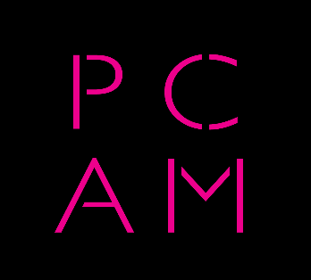

CORONAVIRUS HELP FOR PCAM MEMBERS

Dear PCAM Members,

A lot of help is becoming available for people in our industry who are coping with Covid-19 financially if not physically, and below are some important links.

A fantastic resource, with everything in one place, has been compiled through a collaboration between Help Musicians, the Incorporated Society of Musicians, the Ivors Academy, the Music Managers Forum, the Music Producers Guild, the Musicians’ Union, and UK Music.

The link is: https://www.coronamusicians.info/.

Prager Metis LLP has published two papers on their website that provide a very useful summary of financial advice for those trying to identify government support that may be available for freelancers as well as small businesses. The links are:

https://pragermetis.com/news/self-employment-income-support scheme/
https://pragermetis.com/news/covid-19-support-businesses/

We hope that all of you are managing to stay well and that you can find ways and means to get to the other side of this emergency with your business relatively intact.

Best regards,
The PCAM Committee

